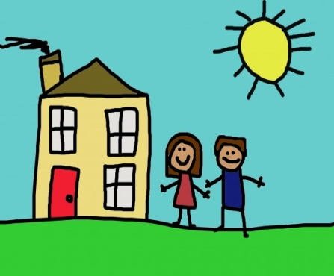 My World 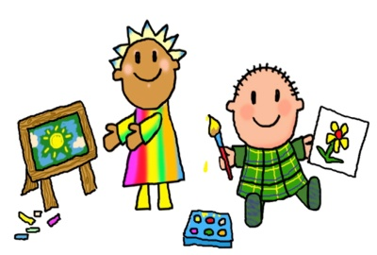
Who are the people in your family?
5 things to do on the way to school.  - Look for the numbers 3 and 4.  - Practise hopping and jumping.  - Sing a nursery rhyme.  - Collect a leaf for our bug hotel.  - Spot things that are your  favourite colour. | What do you see on your journey to school? | 5 fun things to develop fine motor skills  - Rolling balls and sausages with playdough.  - Scrunching up paper.  - Sprinkling toppings on cakes.  - Turning over cards in snap or lotto games.  - Using spray bottles in the bath.

Autumn Term books to read with your child.
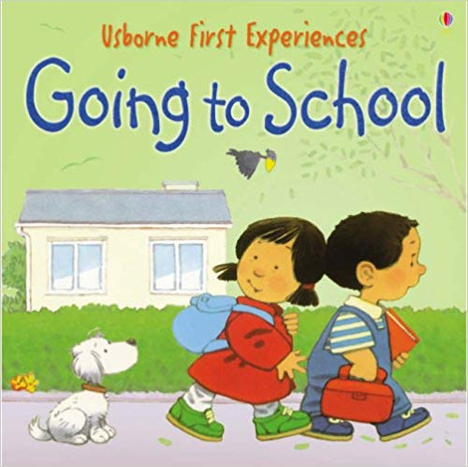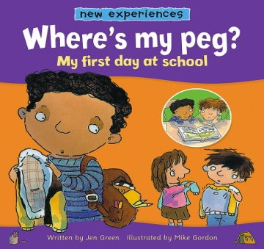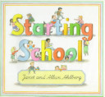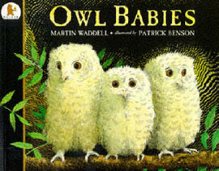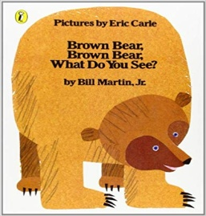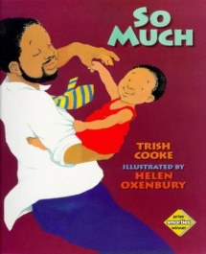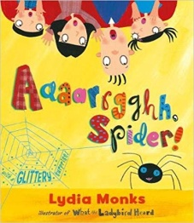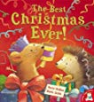
Autumn volcabulary list 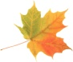 Winter volcabulary list Leaf, tree, windy, rain, conker, acorn, Cold, snow, snowman, ice, icicles, frost, hat, pinecone, squirrel, hibernate, pumpkin, scarf, gloves, boots, coat, sledge, Robin, Harvest, Rosh Hashana, Halloween. Bonfire night, Diwali, Christmas, Hanukkah.

